**Project Report for CSCI 547 Project 1**

By: Pranaya Shrestha

The purpose of this project was to read two ‘.pgm’ images and perform:

1. Contrast Stretching
2. Level Slicing
3. Histogram Equalization

Below are the two images along with their respective pmf and cdf

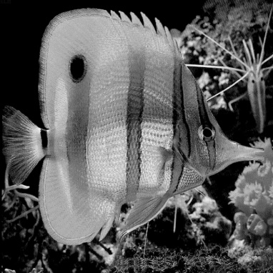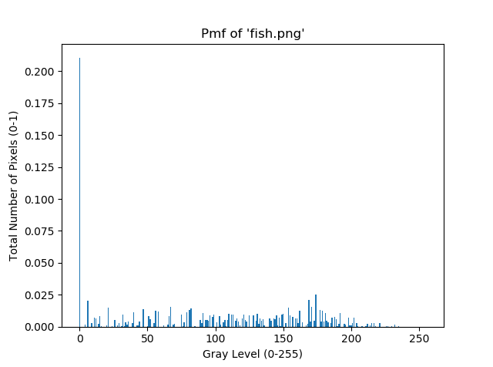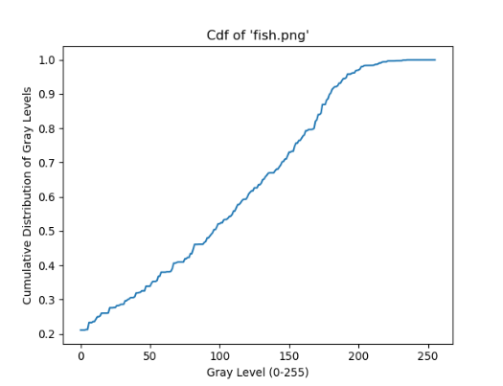

Fish pmf fish cdf fish

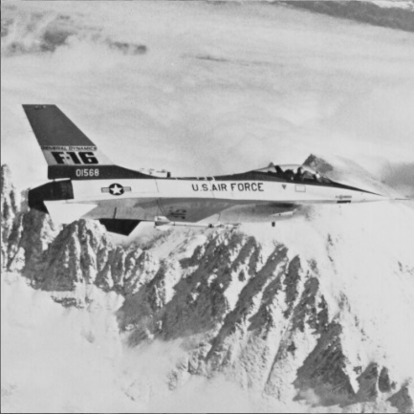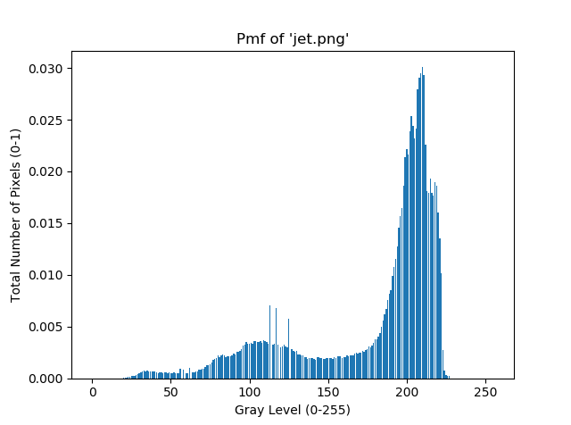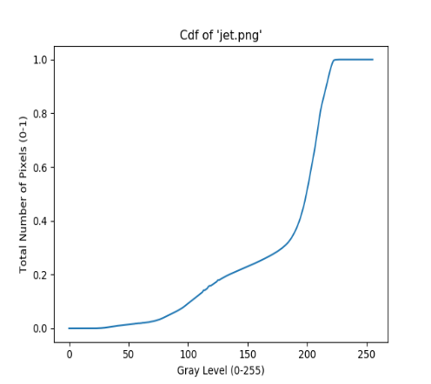

Jet pmf jet cdf jet

**Contrast Stretching**

After setting the pixels with grayscale below 10% on the cdf to black, and pixels above 90% on cdf to white, each pixel between 10% and 90% were linearly stretched to the range 0-255.

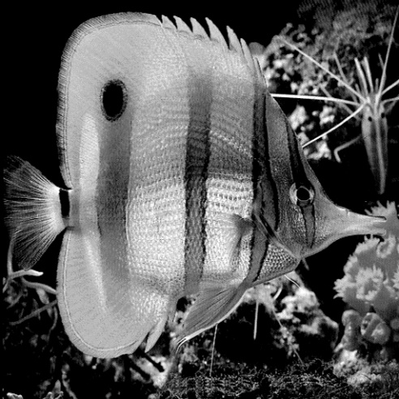 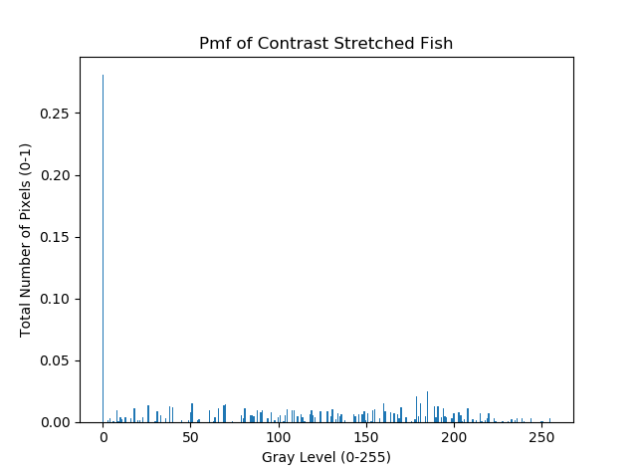

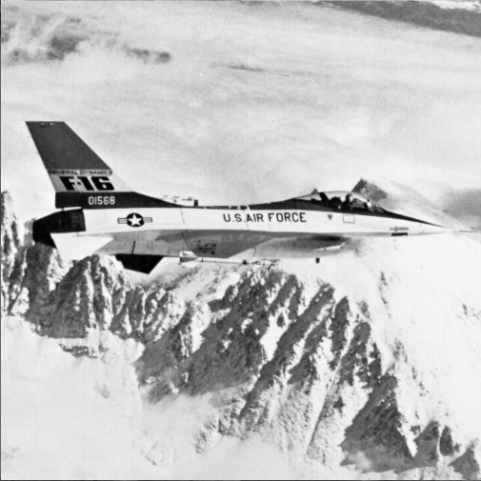 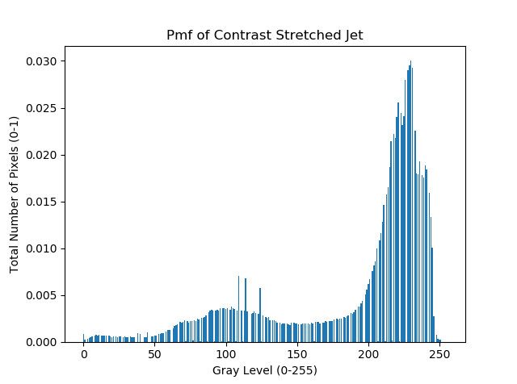

The above two pictures represent the new images after performing the Contrast Stretching on it. Along with it, we can see the new histogram of the stretched images. If we compare the histogram of the stretched images with its original ones, we can definitely see slight differences between them. It seems that the histogram of the original images are more compact than the histograms of the stretched images

**Level Slicing**

For this, I chose the grayscale 0. So, the pixels with grayscale in the range (0 – 10) were set to white and the rest were set to black. Therefore, the final picture will have grayscale either 0 or 255. The results were interesting.

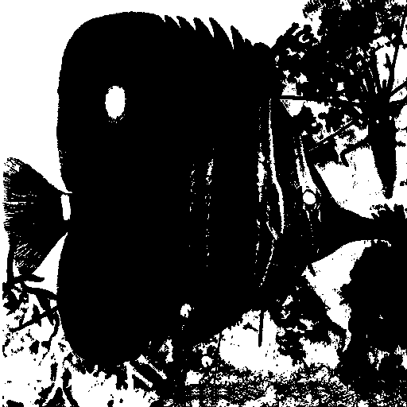 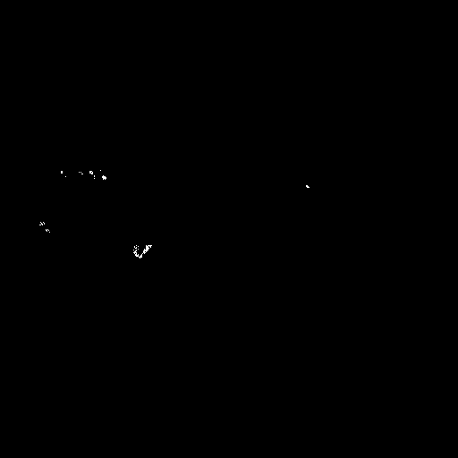

We can see a fish on the left, but cannot see the jet on the right. It is because most of the pixels in the ‘jet.pgm’ file is bright, so it does not fall in the range of (0-10). And thus, becomes black after performing the slicing. However, if we scale the value of L, which is 0 in this case, properly, we can se a significant change in the result

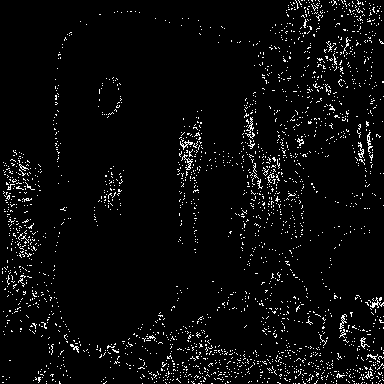 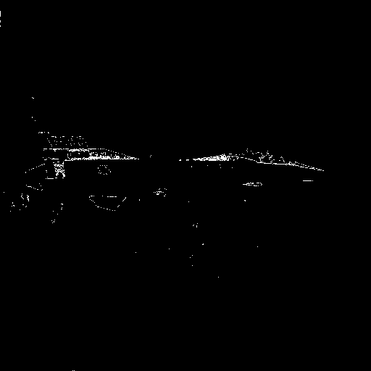

This is when, L is set to 50. We can see an outline for the jet image. But, the clarity on the fish decreases.

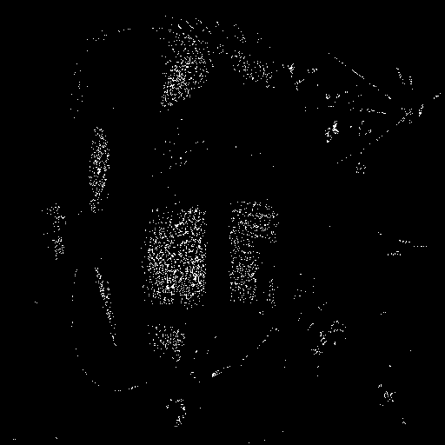 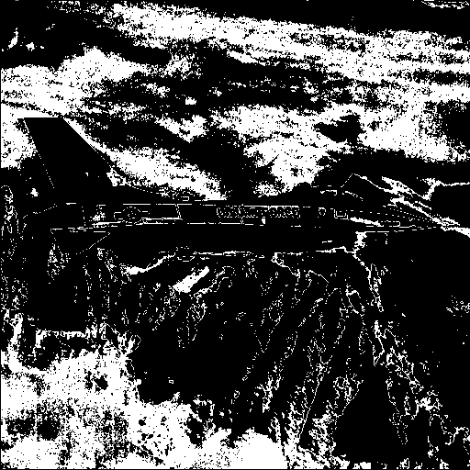

This is when, L is set to 200. Now, we can see the jet more clearly, but the fish less clear. In my opinion, the two images are kind of opposite type images. It means that fish.pgm is darker sided image, whereas, jet.pgm is a brighter image. So, when performing histogram equalization, the fish image should turn brighter and the jet image should turn little darker.

**Histogram Equalization**

To perform histogram equalization, we first find the probability mass function for our image. Then we calculate our cumulative density function(cdf). Then we multiply the cdf with 255, which is our maximum grayscale. Then we round off the value and then map the new value of our cdf*255 with the old value of grayscale, and assign each pixel of our image the new value.

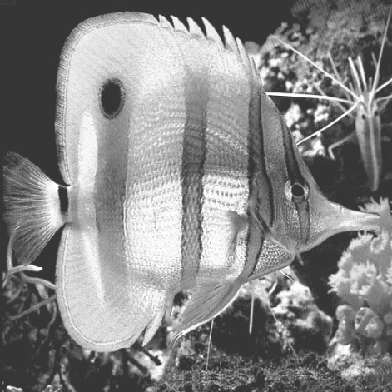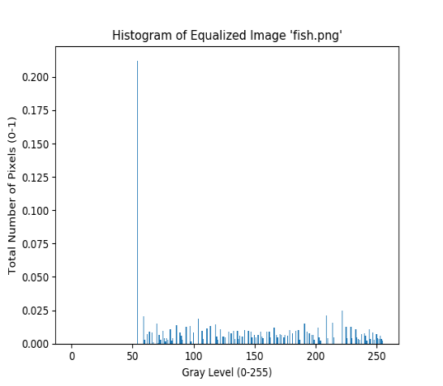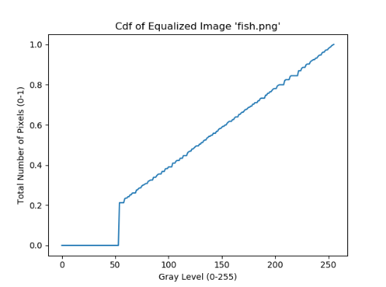

Fish after histogram equalization pmf of new image cdf of new image

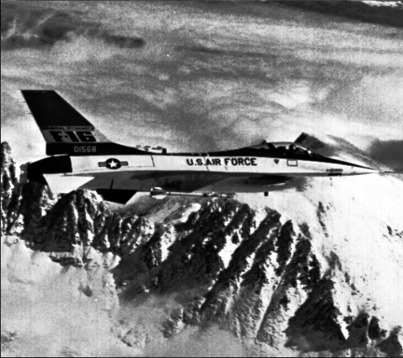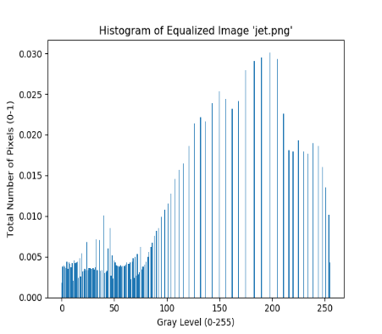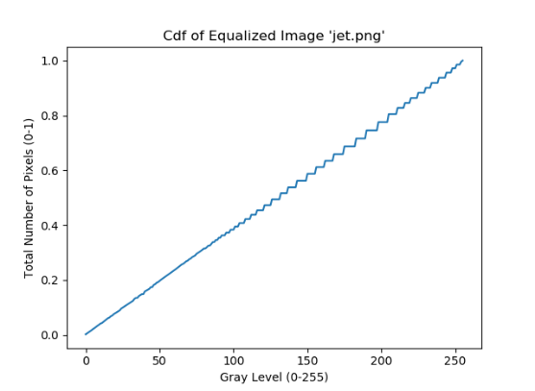

Jet after histogram equalization pmf of new image cdf of new image

The above images represent the images after performing the histogram equalization on the original ones. As we discussed earlier, the fish image is now brighter compared to the original one, whereas, the jet image is slightly darker compared to the original one.

**Conclusion**

The main idea from this project that I got was, performing contrast stretching, image slicing, histogram equalization and many more image processing formulas are ways to enhance details of images. Depending on the image type and your expected result, you need to process you images differently.